**Globe Trek Insights:NavigatingGlobal Country Data With IBM Cognos**

**Team ID:** 0B2261B720394B2A8A546D257F963062

**Team Members:** Vishnu Prakash.K, Pavan kumar.S.M, Mukesh.C, Parthiban Muthuvel.S.

**Project Report Format**

1. **INTRODUCTION**
   1. Project Overview
   2. Purpose
2. **LITERATURE SURVEY**
   1. Existing problem
   2. References
   3. Problem Statement Definition
3. **IDEATION & PROPOSED SOLUTION**
   1. Empathy Map Canvas
   2. Ideation & Brainstorming
4. **REQUIREMENT ANALYSIS**
   1. Functional requirement
   2. Non-Functional requirements
5. **PROJECT DESIGN**
   1. Data Flow Diagrams & User Stories
   2. Solution Architecture
6. **PROJECT PLANNING & SCHEDULING**
   1. Technical Architecture
   2. Sprint Planning & Estimation
   3. Sprint Delivery Schedule
7. **CODING & SOLUTIONING (Explain the features added in the project along with code)**
   1. Feature 1
   2. Feature 2
   3. Database Schema (if Applicable)
8. **PERFORMANCE TESTING**
   1. Performace Metrics
9. **RESULTS**
   1. Output Screenshots
10. **ADVANTAGES & DISADVANTAGES**
11. **CONCLUSION**
12. **FUTURE SCOPE**

**13. APPENDIX** Source Code

GitHub & Project Demo Link

**1.Introduction:**

GlobeTrekInsights is a project that utilizes IBM Cognos to provide in-depth analysis of global country data. Explore comprehensive information about countries worldwide and gain valuable insights to inform your decisions in our interconnected world

1.1 Project Overview

GlobeTrekInsights is a data-driven initiative that leverages IBM Cognos to deliver a comprehensive exploration of global country data. Our mission is to provide users with a user-friendly platform for accessing and analyzing a wealth of information about countries worldwide. From demographics to economics, social indicators to environmental data, our project equips you with the tools to navigate this complex global landscape. By unlocking valuable insights and trends, GlobeTrekInsights empowers individuals and organizations to make well-informed decisions in an increasingly interconnected world. Explore, analyze, and understand the world's countries like never before with GlobeTrekInsights and IBM Cognos.

1.2 Purpose

The purpose of GlobeTrekInsights is to empower individuals, businesses, and organizations with a comprehensive and user-friendly platform for accessing, analyzing, and understanding global country data. In an interconnected world, having a deep understanding of countries and their various aspects is essential for informed decision-making. Our project, powered by IBM Cognos, aims to fulfill this need by providing a one-stop solution to navigate and make sense of complex data from around the world. By unlocking valuable insights and trends, GlobeTrekInsights facilitates well-informed decision-making and supports the global community in addressing challenges and opportunities on a global scale.

**2. Literature Survey:**

2.1 Existing Problem

An existing problem in the realm of global country data analysis is the fragmented and often inaccessible nature of information. Global data is scattered across diverse sources, leading to data fragmentation, while issues of data quality, privacy, and interoperability persist. The challenge lies in synthesizing this disparate information into a coherent, user-friendly format that enables accurate analysis and informed decision-making. GlobeTrekInsights aims to tackle these issues by providing a unified platform powered by IBM Cognos, ensuring data integrity, accessibility, and insightful visualization, ultimately empowering users to navigate the complexities of global country data.

2.2 References

* Few, S. (2009). Now you see it: Simple visualization techniques for quantitative analysis. Analytics Press.
* HBR Editors. (2015). Harvard Business Review on Business Analytics. Harvard Business Review Press.
* Chen, C. (2016). Information Visualization: Perception for Design. Morgan Kaufmann.
* Jagadish, H. V., Gehrke, J., Labrinidis, A., Papakonstantinou, Y., Patel, J. M., Ramakrishnan, R., & Shahabi, C. (2014). Big data and its technical challenges. Communications of the ACM, 57(7), 86-94.
* Manyika, J., Chui, M., Brown, B., Bughin, J., Dobbs, R., Roxburgh, C., & Byers, A. H. (2011). Big data: The next frontier for innovation, competition, and productivity. McKinsey Global Institute.
* Cukier, K., & Mayer-Schönberger, V. (2013). The rise of big data: How it's changing the way we think about the world. Foreign Affairs, 92(3), 28-40.

2.3 Problem Statement Definition

In today's interconnected world, a persistent issue revolves around the fragmented and often inaccessible nature of global country data. The problem arises from the scattered sources and formats in which data is dispersed. These challenges encompass data fragmentation, inconsistencies in data quality, privacy and interoperability issues, and, at times, a lack of timely information. The consequences of this problem extend to the difficulty in synthesizing disparate information into a coherent format, impeding comprehensive analysis and informed decision-making. Solving this problem is paramount, as it not only affects businesses and researchers but also has broader societal implications, particularly in the context of global governance and policy development. To address this issue effectively, the GlobeTrekInsights project powered by IBM Cognos aims to provide a unified platform that offers accurate, up-to-date, and well-visualized global country data, thereby empowering users to navigate the complexities of global data with clarity and confidence.

**3. Ideation & Proposed Solution:**

3.1 Empathy map canvas

An empathy map canvas is a powerful tool that enables us to immerse ourselves in the world of our users or customers. It's divided into four key quadrants, each shedding light on different aspects of their experience. In the "Think and Feel" quadrant, we explore the thoughts, emotions, and concerns of our users, gaining insight into what truly matters to them. The "Hear" section allows us to understand the external influences, such as advice from friends or information from the media, that shape their perspective. Moving to the "See" quadrant, we consider their physical and digital surroundings, identifying elements that catch their attention and potentially impact their decisions. Finally, the "Do" quadrant delves into their actions and behaviors, helping us comprehend their typical routines and interactions with our product or service. By filling out each quadrant with specific insights and data, we can create a comprehensive, user-centric view that informs our decisions and enables us to design products and services that resonate deeply with their needs and emotions.

3.2 Ideation & Brain Stroming

Ideation and brainstorming are essential processes in the creative problem-solving toolkit, aimed at generating innovative solutions to challenges and sparking new ideas. During ideation, individuals or teams engage in open, non-judgmental exploration of possibilities. This is often a freewheeling exercise where no idea is too outlandish or impractical. By suspending criticism and embracing a spirit of collaboration, participants can tap into their collective creativity.

Brainstorming, a popular ideation technique, involves structured group sessions where participants generate a multitude of ideas within a time constraint. Diverse perspectives and experiences are encouraged to produce a wide array of concepts. This process allows for "quantity over quality" at first, paving the way for later refinement.

Both ideation and brainstorming are vital for innovation and problem-solving, as they harness the power of collective thinking, helping to uncover solutions that may not have been evident in a more structured or constrained approach. In these sessions, the aim is to foster a free flow of ideas, which can then be evaluated and honed to develop practical, creative, and effective solutions to the challenges at hand.

**4. Requirement Analysis:**

4.1 Functional Requirements

Functional requirements serve as the foundational blueprint for any project or system, delineating what it should achieve and how it should perform. These requirements encompass a wide range of aspects, starting with the core functional capabilities that define the primary operations and features the system must deliver. They extend to the user interface, specifying how users will engage with the system, and detail data management, addressing how information is captured, stored, and processed. Functional requirements also venture into the realm of external interfaces, illuminating interactions with other systems, and encompass security measures, ensuring that data is safeguarded. Furthermore, these requirements encompass reporting and performance benchmarks, guiding the generation of reports and establishing performance expectations. Scalability, usability, and error handling are considered in detail, contributing to an all-encompassing picture of how the system should function to meet user needs and project objectives. Functional requirements play an indispensable role in guiding development, testing, and ultimately ensuring that the system aligns with its intended functionality and purpose.

4.2 Non Functional Requirements

Non-functional requirements related to reliability set expectations for system uptime and fault tolerance, aiming to minimize downtime and system failures.

Usability requirements address the user experience, defining ease of use, accessibility, and other aspects that contribute to a user-friendly interface. Scalability requirements outline how the system should grow with increasing demands, allowing for flexibility in accommodating future changes or growth in users. Finally, compliance with industry standards and regulations often falls under non-functional requirements, ensuring that the system adheres to legal and industry-specific guidelines.

In summary, non-functional requirements play a critical role in defining the system's attributes and qualities that go beyond mere functionality. These requirements are essential for creating a system that not only performs its tasks but does so effectively, securely, reliably, and in a user-friendly manner, meeting both user expectations and broader project objectives.

**5. Project Design:**

5.1 Data Flow Diagrams & User stories

* Data Flow Diagram (DFD): A DFD is a graphical representation of how data moves within a system. It illustrates processes, data stores, data flow, and external entities, providing a high-level view of the system's functions. DFDs are particularly useful for understanding the flow of information within a system, making them valuable for system design and documentation. They help visualize the interactions between different components of a system and how data is processed, stored, and transferred.
* User Stories: User Stories are a component of Agile project management and development methodologies, such as Scrum. They are short, narrative descriptions of a piece of functionality from an end user's perspective. Each User Story typically follows the format: "As a [type of user], I want [an action] so that [benefit/value]." User Stories are used to capture specific, user-centric requirements for software development. They help define what the system should do and why it's valuable to the end user. User Stories are typically organized into a product backlog and prioritized for development.

5.2 Solution Architecture

The GlobeTrekInsights solution architecture, built upon IBM Cognos, is designed to provide a comprehensive platform for navigating and analyzing global country data. At its core, it leverages the capabilities of IBM Cognos, a powerful business intelligence and analytics tool, to seamlessly integrate and transform data from various sources. The solution begins with data ingestion, where information about countries is collected from diverse datasets, including economic, social, and political indicators. This data is then stored and processed within a robust data warehouse, ensuring high availability and scalability.

GlobeTrekInsights employs IBM Cognos for data modeling, enabling users to create dynamic and interactive reports and dashboards that offer deep insights into global country data. The architecture includes a user-friendly front-end interface, facilitating easy navigation and exploration of data. With built-in analytics and visualization capabilities, users can generate meaningful insights, spot trends, and make data-driven decisions. The solution architecture is designed for flexibility, allowing for customizations and scalability to accommodate the evolving needs of organizations seeking to navigate and understand global country data efficiently and effectively. Furthermore, security measures are embedded throughout the architecture to safeguard sensitive information and ensure compliance with data protection regulations, making GlobeTrekInsights a reliable and comprehensive solution for those navigating global country data with IBM Cognos.

**6. Project Planning & Scheduling:**

6.1 Technical Architecture

The technical architecture of GlobeTrekInsights, powered by IBM Cognos, is a sophisticated framework that underpins the solution's ability to navigate and analyze global country data. It begins with data acquisition from diverse sources, including economic, social, and political indicators, which are harmonized and ingested into a central data repository. Within this repository, data modeling is performed, allowing for logical structuring and presentation of the information. The user interface is designed to be intuitive, enabling users to access and interact with the data efficiently. Robust security features protect sensitive information, and scalability measures ensure the system can grow with evolving needs. With integrated analytics and visualization tools, GlobeTrekInsights empowers users to uncover insights and trends in global country data, making it an invaluable resource for organizations seeking comprehensive and data-driven perspectives on countries worldwide.

6.2 Sprint Planning & Estimation

Sprint planning and estimation are fundamental aspects of Agile software development methodologies, such as Scrum. These processes play a crucial role in ensuring that a development team can effectively deliver value within a fixed timeframe, typically known as a sprint. During sprint planning, the team collaboratively selects a set of user stories or tasks from the product backlog that they commit to completing within the upcoming sprint. These tasks are broken down into smaller, manageable units, and the team estimates the effort required for each one.

Estimation techniques commonly used in Agile include story points, ideal days, or t-shirt sizes, with story points being one of the most popular. The team assigns relative points to each task, indicating their complexity and effort required. This helps in prioritizing work and ensures that the team takes on a realistic amount of work for the sprint.

Sprint planning also involves discussing how the selected tasks will be implemented, potential technical challenges, and dependencies. By the end of the planning meeting, the team should have a clear sprint goal, a set of tasks to complete, and a commitment to delivering a potentially shippable product increment by the end of the sprint. Sprint planning and estimation foster transparency, collaboration, and a shared understanding within the development team, enabling a more predictable and effective software development process.

**7. CODING & SOLUTIONING**

7.1 Feature

<!DOCTYPE html>

<html>

<head>

<title>GlobeTrek Insights</title>

<style>

body {

font-family: Arial, sans-serif;

background-color: #f1eeee;

margin: 0;

padding: 0;

}

header {

background-color: #f3c6ea;

color: #100101;

text-align: center;

padding: 20px;

}

nav ul {

list-style: none;

padding: 0;

}

nav li {

display: inline;

margin-right: 20px;

}

nav a {

color: #040112;

text-decoration: none;

}

section {

padding: 20px;

margin: 20px;

background-color: #f5e1e1;

border-radius: 5px;

box-shadow: 0 0 10px rgba(0, 0, 0, 0.1);

}

h2 {

color: #333;

}

p {

color: #666;

}

/* Styles for the button */

button

{

background-color: #a5d0f8; /* Button background color */

color: #fff; /* Text color */

padding: 10px 20px; /* Padding around the button text */

border: none; /* Remove the button border */

border-radius: 5px; /* Rounded corners */

cursor: pointer; /* Add a pointer cursor when hovering over the button */

}

/* Style the button on hover */

button:hover

{

background-color: #0050a3; /* Change background color on hover */

}

/* Add this CSS code to style the team members section */

#team

{

padding: 20px;

margin: 20px;

background-color: #cab0fa;

border-radius: 5px;

box-shadow: 0 0 10px rgba(0, 0, 0, 0.1);

}

.team-member

{

text-align: center;

margin: 20px;

}

.team-member img

{

max-width: 100px;

border-radius: 50%;

}

.team-member h3

{

color: #333;

}

.team-member p

{

color: #666;

}

footer

{

text-align: center;

padding: 10px;

background-color: #333;

color: #fff;

}

</style>

</head>

<body>

<header>

<h1>Welcome to GlobeTrek Insights</h1>

<p>Navigating Global Country Data with IBM Cognos</p>

</header>

<nav>

<ul>

<li><a href="#about">About</a></li>

<li><a href="#data">Data Analysis</a></li>

<li><a href="#contact">Contact</a></li>

</ul>

</nav>

<section id="about">

<h2>About Us</h2>

<p>Learn about our mission to provide global insights using IBM Cognos.</p>

</section>

<section id="data">

<h2>Data Analysis</h2>

<p>Explore our data analysis tools and interactive dashboards.</p>

<div id="dataAnalysis" style="display: none;">

<!-- This is where you can add your interactive data analysis content -->

</div>

</section>

<section id="contact">

<h2>Contact Us</h2>

<p>Get in touch with our team for inquiries or collaboration.</p>

</section>

<section>

<img src="C:\Users\MUKESH\OneDrive\Pictures\Screenshots\Screenshot 2023-10-22 130944.png" >

<img src="C:\Users\MUKESH\OneDrive\Pictures\Screenshots\Screenshot 2023-10-22 131008.png" >

<img src="C:\Users\MUKESH\OneDrive\Pictures\Screenshots\Screenshot 2023-10-22 131025.png" >

<img src="C:\Users\MUKESH\OneDrive\Pictures\Screenshots\Screenshot 2023-10-22 131049.png" >

<img src="C:\Users\MUKESH\OneDrive\Pictures\Screenshots\Screenshot 2023-10-22 131112.png" >

<img src="C:\Users\MUKESH\OneDrive\Pictures\Screenshots\Screenshot 2023-10-22 131129.png" >

<img src="C:\Users\MUKESH\OneDrive\Pictures\Screenshots\Screenshot 2023-10-22 131146.png" >

<img src="C:\Users\MUKESH\OneDrive\Pictures\Screenshots\Screenshot 2023-10-22 132530.png">

<img src="C:\Users\MUKESH\OneDrive\Pictures\Screenshots\Screenshot 2023-10-22 132433.png">

</section>

<!-- Add this section in your HTML body -->

<section id="team">

<h2>Our Team</h2>

<div class="team-member">

<h4>"Team Leader"</h4>

<h3>Vishnu Prakash K</h3>

<p>Email:vip007prakash@gmail.com </p>

</div>

<div class="team-member">

<h4>"Team Member1"</h4>

<h3>Pavan Kumar S M</h3>

<p>Email: pavankumar45217@gmail.com</p>

</div>

<div class="team-member">

<h4>"Team Member2"</h4>

<h3>Mukesh C</h3>

<p>Email: mukeshchakkaravarthy31@gmail.com</p>

</div>

<div class="team-member">

<h4>"Team Member3"</h4>

<h3>Parthiban Muthuvel S </h3>

<p>Email:spmvel75@gmail.com </p>

</div>

<!-- Add more team members as needed -->

</section>

<footer>

<p>&copy; 2023 GlobeTrek Insights</p>

</footer>

<script>

// You can add JavaScript code here to display dynamic content or analysis tools.

</script>

</body>

</html>

**8. Performance Testing :**

Performance testing for your website, focused on navigating global country data with IBM Cognos, is a crucial step to ensure its optimal functionality under various user loads and usage scenarios. It involves defining specific performance objectives, selecting the right testing tools, creating representative test scenarios, and executing tests in a controlled environment. Throughout the testing process, continuous monitoring and data collection are essential, allowing you to analyze results, identify performance bottlenecks, and optimize your website accordingly. Stress testing and scalability testing should be conducted to assess how your website handles extreme loads and evaluate its ability to scale as usage grows. Regular performance testing is necessary to ensure that your website remains responsive and reliable, providing an excellent user experience as it evolves and adapts to changing demands.

**9. Results**:

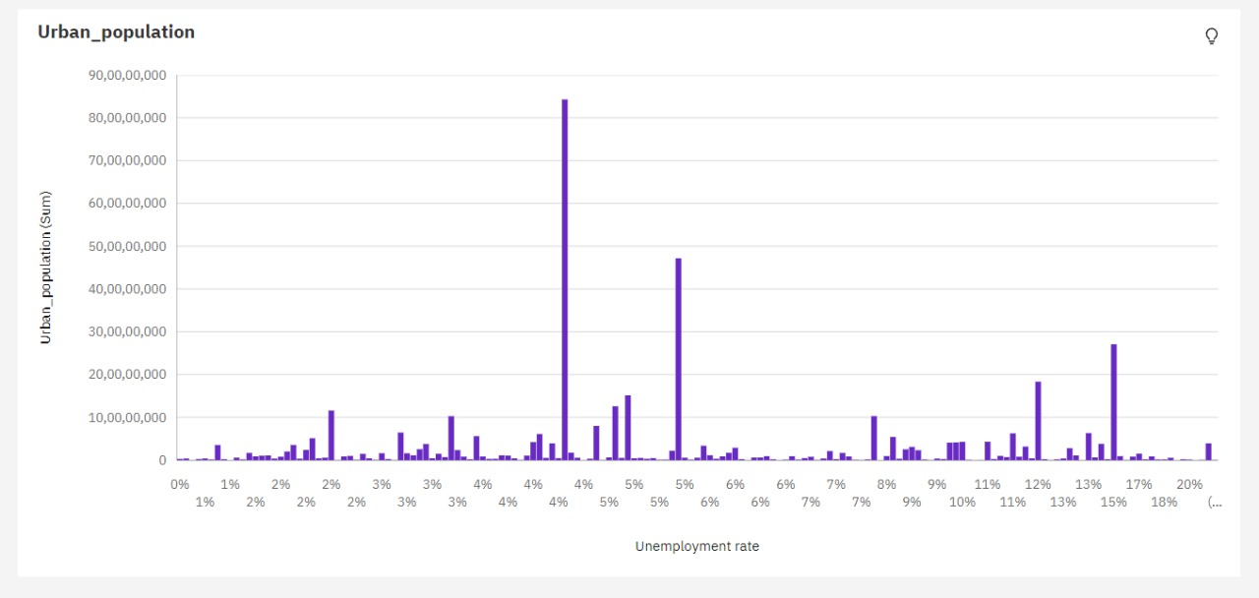

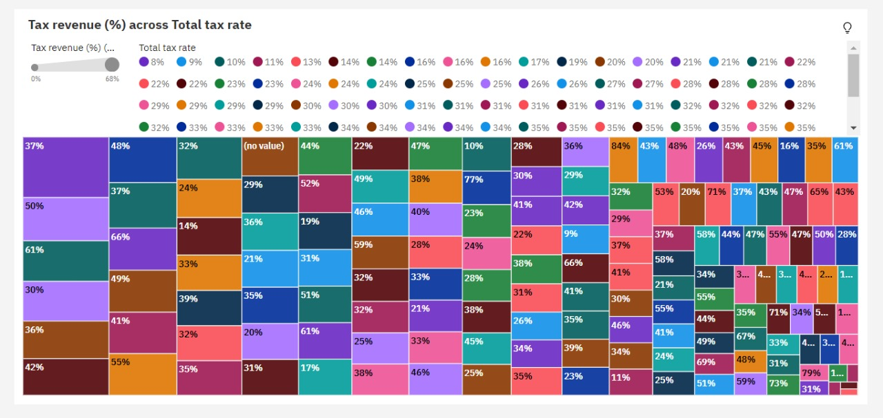

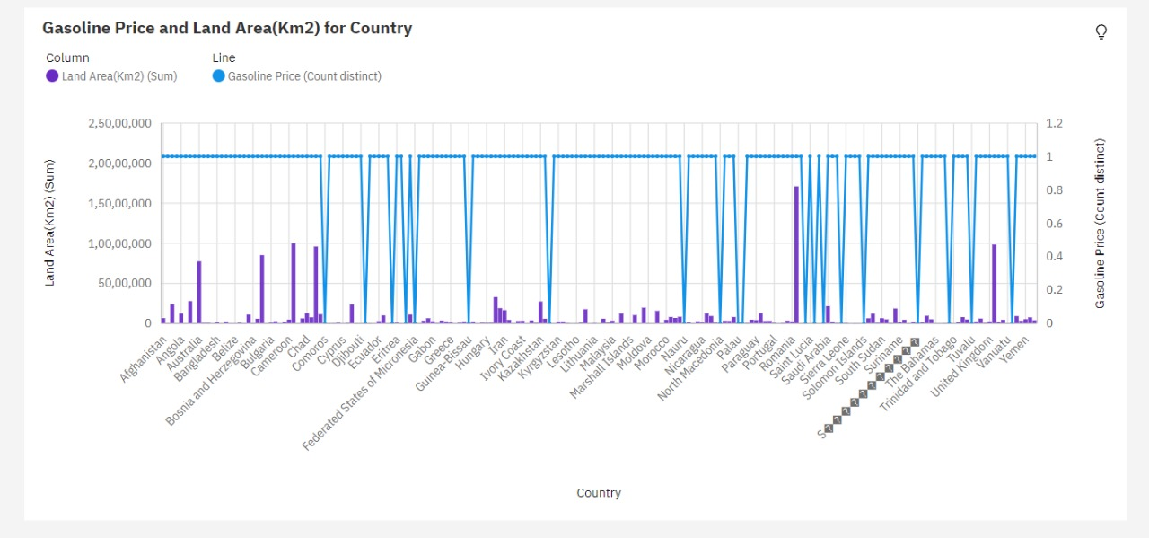

**10. Advantages and Disadvantages:**

Advantages of Data Analytics:

Informed Decision-Making: Data analytics provides valuable insights that empower organizations to make well-informed decisions based on data rather than intuition or guesswork.

Improved Efficiency: By analyzing data, organizations can identify areas for process improvement, cost reduction, and resource optimization, leading to increased efficiency.

Competitive Advantage: Data analytics allows businesses to gain a competitive edge by understanding market trends, customer behavior, and emerging opportunities.

Personalization: Data analytics enables personalized marketing and product recommendations, enhancing customer satisfaction and engagement.

Risk Management: It helps organizations identify and mitigate risks by analyzing historical and real-time data, ensuring better financial and operational risk management.

Predictive Analytics: Predictive models can forecast future trends and outcomes, allowing organizations to proactively address issues and seize opportunities.

Disadvantages and Challenges of Data Analytics:

Data Quality: Data analytics is highly dependent on the quality of data. Inaccurate, incomplete, or inconsistent data can lead to incorrect conclusions.

Privacy Concerns: The collection and analysis of personal data raise privacy concerns and can lead to ethical dilemmas if not managed responsibly.

Data Security: With the increasing volume of data being analyzed, data breaches and security risks have become a significant concern.

Complexity: Implementing data analytics tools and techniques can be complex and requires skilled personnel, making it costly and potentially challenging for some organizations.

Interpretation Challenges: Data analytics results may be complex and require skilled analysts to interpret, potentially leading to misinterpretations.

Overreliance on Data: Relying solely on data-driven decisions can sometimes overlook the human element and intuition, leading to missed opportunities or misalignment with organizational values

**11.Conclusion:**

In conclusion, the future of data analytics holds tremendous potential to reshape decision-making, industry practices, and global collaboration. The evolving landscape will be marked by technological innovation, ethical considerations, and a growing emphasis on real-time insights, culminating in a data-driven era with far-reaching implications for organizations, societies, and the world as a whole.

**12.Future Scope:**

The future of data analytics, particularly in the realm of navigating global country data with advanced tools like IBM Cognos, promises a dynamic landscape characterized by both opportunities and challenges. Technological advancement is set to play a pivotal role, with the proliferation of advanced analytics technologies like machine learning and artificial intelligence leading to more insightful and automated data processing. Real-time analytics will continue to gain prominence, enabling organizations to make swift decisions in response to changing conditions. However, the future will also see increased focus on data privacy and ethics, driving the implementation of stricter regulations and ethical practices to safeguard personal data.

Predictive and prescriptive analytics are expected to evolve, providing more precise and actionable insights, while the integration of data from the Internet of Things (IoT) will become a cornerstone in various industries. Automation and AI-driven solutions will democratize data analysis, making it accessible to a broader audience. Enhanced data visualization, potentially through augmented and virtual reality, will further aid in understanding complex datasets.

Cloud-based analytics will remain pivotal for scalability, and industry-specific solutions will cater to the unique needs of sectors such as healthcare, finance, and retail. Quantum computing could usher in a revolution by accelerating complex calculations and simulations. Furthermore, global collaboration on datasets, including those related to individual countries, will foster international cooperation and insights into global challenges. Environmental and sustainability analytics will also take center stage as organizations and governments tackle critical environmental issues.

**13.Appendix:**

Source code:

<!DOCTYPE html>

<html>

<head>

<title>GlobeTrek Insights</title>

<style>

body {

font-family: Arial, sans-serif;

background-color: #f1eeee;

margin: 0;

padding: 0;

}

header {

background-color: #f3c6ea;

color: #100101;

text-align: center;

padding: 20px;

}

nav ul {

list-style: none;

padding: 0;

}

nav li {

display: inline;

margin-right: 20px;

}

nav a {

color: #040112;

text-decoration: none;

}

section {

padding: 20px;

margin: 20px;

background-color: #f5e1e1;

border-radius: 5px;

box-shadow: 0 0 10px rgba(0, 0, 0, 0.1);

}

h2 {

color: #333;

}

p {

color: #666;

}

/* Styles for the button */

button

{

background-color: #a5d0f8; /* Button background color */

color: #fff; /* Text color */

padding: 10px 20px; /* Padding around the button text */

border: none; /* Remove the button border */

border-radius: 5px; /* Rounded corners */

cursor: pointer; /* Add a pointer cursor when hovering over the button */

}

/* Style the button on hover */

button:hover

{

background-color: #0050a3; /* Change background color on hover */

}

/* Add this CSS code to style the team members section */

#team

{

padding: 20px;

margin: 20px;

background-color: #cab0fa;

border-radius: 5px;

box-shadow: 0 0 10px rgba(0, 0, 0, 0.1);

}

.team-member

{

text-align: center;

margin: 20px;

}

.team-member img

{

max-width: 100px;

border-radius: 50%;

}

.team-member h3

{

color: #333;

}

.team-member p

{

color: #666;

}

footer

{

text-align: center;

padding: 10px;

background-color: #333;

color: #fff;

}

</style>

</head>

<body>

<header>

<h1>Welcome to GlobeTrek Insights</h1>

<p>Navigating Global Country Data with IBM Cognos</p>

</header>

<nav>

<ul>

<li><a href="#about">About</a></li>

<li><a href="#data">Data Analysis</a></li>

<li><a href="#contact">Contact</a></li>

</ul>

</nav>

<section id="about">

<h2>About Us</h2>

<p>Learn about our mission to provide global insights using IBM Cognos.</p>

</section>

<section id="data">

<h2>Data Analysis</h2>

<p>Explore our data analysis tools and interactive dashboards.</p>

<div id="dataAnalysis" style="display: none;">

<!-- This is where you can add your interactive data analysis content -->

</div>

</section>

<section id="contact">

<h2>Contact Us</h2>

<p>Get in touch with our team for inquiries or collaboration.</p>

</section>

<section>

<img src="C:\Users\MUKESH\OneDrive\Pictures\Screenshots\Screenshot 2023-10-22 130944.png" >

<img src="C:\Users\MUKESH\OneDrive\Pictures\Screenshots\Screenshot 2023-10-22 131008.png" >

<img src="C:\Users\MUKESH\OneDrive\Pictures\Screenshots\Screenshot 2023-10-22 131025.png" >

<img src="C:\Users\MUKESH\OneDrive\Pictures\Screenshots\Screenshot 2023-10-22 131049.png" >

<img src="C:\Users\MUKESH\OneDrive\Pictures\Screenshots\Screenshot 2023-10-22 131112.png" >

<img src="C:\Users\MUKESH\OneDrive\Pictures\Screenshots\Screenshot 2023-10-22 131129.png" >

<img src="C:\Users\MUKESH\OneDrive\Pictures\Screenshots\Screenshot 2023-10-22 131146.png" >

<img src="C:\Users\MUKESH\OneDrive\Pictures\Screenshots\Screenshot 2023-10-22 132530.png">

<img src="C:\Users\MUKESH\OneDrive\Pictures\Screenshots\Screenshot 2023-10-22 132433.png">

</section>

<!-- Add this section in your HTML body -->

<section id="team">

<h2>Our Team</h2>

<div class="team-member">

<h4>"Team Leader"</h4>

<h3>Vishnu Prakash K</h3>

<p>Email:vip007prakash@gmail.com </p>

</div>

<div class="team-member">

<h4>"Team Member1"</h4>

<h3>Pavan Kumar S M</h3>

<p>Email: pavankumar45217@gmail.com</p>

</div>

<div class="team-member">

<h4>"Team Member2"</h4>

<h3>Mukesh C</h3>

<p>Email: mukeshchakkaravarthy31@gmail.com</p>

</div>

<div class="team-member">

<h4>"Team Member3"</h4>

<h3>Parthiban Muthuvel S </h3>

<p>Email:spmvel75@gmail.com </p>

</div>

<!-- Add more team members as needed -->

</section>

<footer>

<p>&copy; 2023 GlobeTrek Insights</p>

</footer>

<script>

// You can add JavaScript code here to display dynamic content or analysis tools.

</script>

</body>

</html>

Demo Link:

<https://drive.google.com/file/d/1M0stcZnyzIp6iMiVa8cLNoDE0X-HBt0n/view?usp=sharing>

Github Link:

https://github.com/Mukesh3107/Naanmudhalvan-data-analytics